THE ALTERNATIVE QUESTIONS PATHWAY
BLUE MEANS DO IT FIRST SO YOU DON’T SKIP IT (HIGHEST PRIORITY)
Also, I love you all and it’s okay if you don’t complete everything. Your world won’t end if you have 3 Cardio videos left at the end of the week. Take care of yourselves and try and keep your mental health intact. MENTAL HEALTH NOTE ON THE VERY LAST PAGE
 | Monday | Tuesday | Wednesday | Thursday | Friday | Saturday | sunday
Week 5 TOPICS | GGOER
Questions (AMBOSS or Rx) |  | Exam | Rest | 44 GI (1 hammers/easy) add incorrects to anki | 35 GI(2 hammer/easy) add incorrects to anki | 35 cardio(2 hammer/easy) add incorrects to anki
VIDEOS
First aid pages discussed with study group) |  |  |  | 358-365 | 367-373 | 374-381 | 6 pages
Review  Sketchy |  |  |  | -histoplasmosis  -blastomycosis  -VZV  -antiemetics  -heparin | -coccidiomycosis  -paracoccidioides  -HHV-6 roseola  -H2 receptor blockers  -warfarin | -malesia furfur  - dermatophytes  -HHV-8 kaposi  -laxatives  -antiplatelet | Dyslipidemia drug,  -norwalk
ANKI | Filter decks everyday Anki filter deck how-to video DO IT!!!!!! Best thing I did in term 5 & dedicated (presetup in my deck if you haven't ever used anki before)
Week 2 | GI/endocrine
Questions | 27 GI (3 hammer)  +12 endocrune (1 hammer) | 27 GI l (3 hammer)  +13 endocrine(1hammer) | 47 endocrine(2 hammer) | 25 endocrine (3 hammer)  +10 GI (1-3 hammer) | 25 endocrine(3 hammer)  +10 GI (1-3 hammer) | Sakai questions  +10 GI (1-3 hammer)
Videos | Use B&B list, sketchy path, pharm, micro list. Watch videos on things you got wrong in your daily questions. It should take 1 hour to do questions, 3-4 to review questions, and 2 hours to watch videos on topics you got incorrect. That's 7 hours a day.
First aid pages | 382-389 | 390-397 | 398-401
FTM review  (+annotate) | Day 11 FTM review schedule | Day 12 FTM review schedule | Day 13 FTM review schedule | Day 14 FTM review schedule | Day 15 FTM review schedule | 10-20 Rx biochem
Sketchy Review | -ACE inhibitors  -C. Perfringens  -C.diphtheriae  -flavi virus | -Acetazolamide  -listeria mono  -actinomyces  -Hep C | -Loop diuretics  -nocardia  -neisseria overview  -togavirus | Thiazides  -neisseria meningitidis  -neisseria gonorrhoeae  -corona virs | K-sparing diuretics  -klebsiella  -proteus  -HIV | -salmonella  -shigella  -orthomyxo
Sketchy path | 3 videos per day (16 videos total)  Sketchy path for renal is absolutely bomb and has gotten me so many questions. If you have time add it in PLEASE. (yes the nephritic disorders one sucks but the rest rock)
Week 3 | Rheumatology, immunodeficiencies, vasculitis, hypersensitivity
Questions (AMBOSS) | 31pulm (1 hammer)  +10 mixed 1-3 hammer (GI, endocrinel) | 30 pulm(2 hammer)  +10 mixed 1-3 hammer (GI, endocrinel) | 30 pulm(2 hammer)  +10 mixed 1-3 hammer (GI, endocrinel) | 28 pulm( 3 hammer)  +10 mixed 1-3 hammer (GI, endocrinel) | 28 pulm( 3 hammer)  +10 mixed 1-3 hammer (GI, endocrinel) | 19 pulm (4 hammer)
Videos | Use B&B list, sketchy path, pharm, micro list. Watch videos on things you got wrong in your daily questions. It should take 1 hour to do questions, 3-4 to review questions, and 2 hours to watch videos on topics you got incorrect. That's 7 hours a day.
First aid pages | 4 pages resp per day
FTM review  (+annotate) | Day 16 FTM review schedule | Day 17 FTM review schedule | Day 18 FTM review schedule | Day 19 FTM review schedule | Day 20 FTM review schedule | Day 1 FTM review schedule
Sketchy review | Asthma therapy  -E.coli  -yersinia  -paramyxo | Antihistamines  -campylobacter  -cholera  -rhabdovirus | Prostaglandins  -helicobacter  -pseudomonas  -filovirus | -RIPE drugs  -Leprosy drugs  -TB  -leprosy  -bunyavirus | -Cholinomimetics  -bordetella  -H.influenza  -arenavirus | -Acetylcholinesterase inhibitors  -legionella  -bartonella hensley  -reovirus
Week 4 | Repro (tough week, do your best)
Questions | 37 hemOnc(1 hammer)  +10 mixed cardio & renal (1-3 hammer) | 25 hemOnc (2 hammer) +10 mixed cardio & renal (1-3 hammer) | 25 (hemOnc2 hammer) +10 mixed cardio & renal (1-3 hammer) | 27 hemOnc(3 hammer)+10 mixed cardio & renal (1-3 hammer) | 27 hemOnc (3 hammer) +10 mixed cardio & renal (1-3 hammer) | 23 hemOnc(4 hammer) +10 mixed cardio & renal (1-3 hammer)
videos | Use B&B list, sketchy path, pharm, micro list. Watch videos on things you got wrong in your daily questions. It should take 1 hour to do questions, 3-4 to review questions, and 2 hours to watch videos on topics you got incorrect. That's 7 hours a day. SKETCHY PATH IS AWESOME FOR WBC CANCERS
First aid pages
Sketchy review | -brucella  -francisella  -HSV  -methotrexate | -pasteurella  -borrelia  -adenovirus  -thrombolytic therapy  -cisplatin | -leptospira  -treponema  -poxvirus  -azathioprine  -vixenchristine | -chlamydia  -coxiella  -Hep B  -antiplatelet drugs  -cyclophosphamide | -gardnerella  -mycoplasma  -EBV  -heparin  -etoposide | -all 3 rickettsia videos  -CMV  -warfarin  -bleomycin
Week 5 | Exam
 | Review 1st weeks lectures  +sketchies/pixorizes  +2 hematology lectures | Review 2nd weeks lectures  +sketchies/pixorizes  +2 hematology lectures | Review 3rd weeks lectures  +sketchies/pixorizes  +2 hematology lectures | REVIEW GENERAL PATH & BIOSTATS ONLY TODAY. RELAX  Read pathoma chapter  1-3  BIOSTATS YOUTUBE  https://www.youtube.com/watch?v=75pQPB1RF50  https://www.youtube.com/watch?v=VMI9UuNqoGI | EXAM | RELAX
*FA pages correlate to 2020 version

INSTRUCTIONS FOR REVIEWING QUESTION BLOCKS

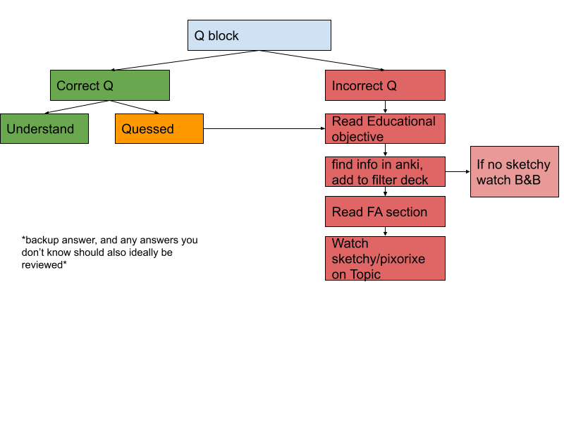

Sketchy checklist and B&B checklist added to term 4 drive!

The key to the first BSCE is to keep up with learning pathophysiology while simultaneously realizing most of what you’ll be tested on is FTM
IF YOU ARE WEAK ON FTM PLEASE FOCUS ON THAT FIRST AND MAKE IT YOUR PRIMARY FOCUS. I’m gonna repeat this. LEARN FTM, ok? Like, really. I’d rather you skip all of cardio for FTM (not recommended but still) FTM=Cell bio, genetics, metabolism, vitamins, DNA, ect.

Pathophysiology: the teacher will hint at things being on the exam, he has no control of questions, and they won’t show up. SKIP ALL LECTURES (unless you genuinely enjoy them)

Biggest regret of term 5: Not using sketchy path more, really, it’s time now. You’ve seen all the pharm and micro multiple times if you’ve been following my schedules. Now it’s time to up your game and add path.

Resources

-For FTM/biochem/genetics
Pixorize: if sketchy helps you at all, this brand does an amazing job at being sketchy for all of FTM. metabolic pathways,fatty acid synthesis, meissner's corpuscles, glycogen storage diseases, and they’re constantly adding new videos. This was a life saver for all the stuff I didn't properly learn 1st year. It’s also still pretty cheap.
https://pixorize.com/browse

-For Physiology/anatomy
Physeo: If Boards and beyond still isn’t cutting it for physiology and anatomy physeo is an excellent resource. It simplifies everything and gives a lot of practice questions as you go. Also relatively cheap (split it with a couple friends)
https://physeo.com/dashboard/

Boards & beyond
-please make sure to annotate well and you won't have to watch a single one during dedicated. Boards and beyond is a lot of work, and sometimes Jason will start going on tangents and you’ll think *this cannot be testable* and you zone out, guarantee the next day you get a question wrong on just that topic. EVERY WORD HE SAYS IS TESTABLE ON STEP. So write it all down in your first aid and you’ll be able to devote all of dedicated to questions.

Sketchy: Obviously.

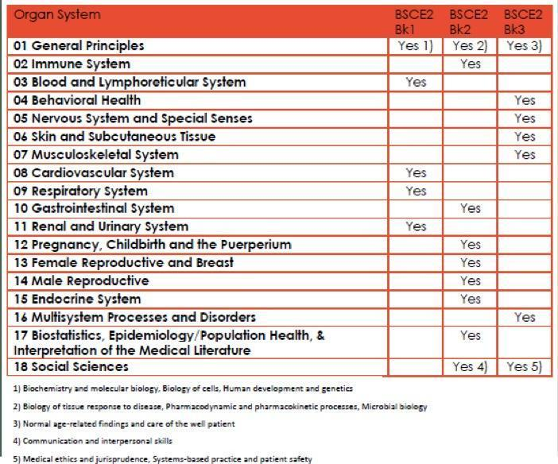

Reminder, there is a light at the end of the tunnel. I had a patient hold my hand this week, I got to hold a scalpel, I got to help decide which antibiotics to give a patient in the ICU. These things matter, I swear. Learn as much as you can.
